**Booklist: Civil Rights Pilgrimage 2024: Living Justice**

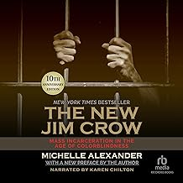**Alexander, Michelle**

The New Jim Crow : mass incarceration in the age of colorblindness. By Michelle Alexander, 2012. (364.9 Ale)

**Branch, Taylor** (we don’t have this title.)

[Parting the Waters : America in the King Years 1954-63](https://www.amazon.com/Parting-Waters-America-Years-1954-63/dp/B00NBO1AHO/ref=sr_1_2?crid=D4TKR0KU31GZ&keywords=Parting+the+waters&qid=1695330503&s=books&sprefix=parting+the+waters%2Cstripbooks%2C160&sr=1-2) is available in several formats from the Seattle Public Library, and the King County Library System, so probably in other public libraries have it as well.

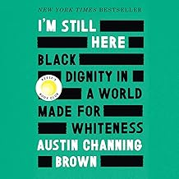**Brown, Austin Channing**

I'm still here : Black dignity in a world made for whiteness. By Austin Channing Brown, 2018 (305.8 Bro)

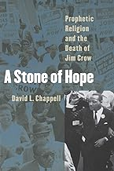**Chapelle, David**

A Stone of hope : prophetic religion and the death of Jim Crow by David Chapelle. 2004 (323.1 Cha)

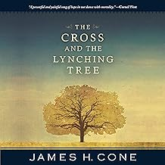**Cone, James**

Cross and the lynching tree, 2011 (277.3 Con)

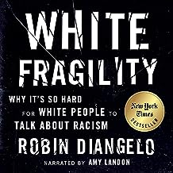**DiAngelo, Robin**

[White fragility : why it's so hard for White people to talk about racism](https://ecww.booksys.net/libs/ecww/AddEditItem?&hint=11618) By Robin DiAngelo. 2018. (305.8 DiA)

## She also a newer title, [Nice Racism: How Progressive White People Perpetuate Racial Harm](https://www.amazon.com/Nice-Racism-Progressive-People-Perpetuate/dp/B08JD3NLXZ/ref=sr_1_1?crid=20OXTH6CAKYC5&keywords=Nice+racism&qid=1695328478&s=books&sprefix=nice+racism%2Cstripbooks%2C156&sr=1-1), 2021. (305.8 DiA)

**Duncan, Lenny**

[Dear church : a love letter from a black preacher to the whitest denomination in the U.S.](https://ecww.booksys.net/libs/ecww/AddEditItem?&hint=11834) By Lenny Duncan. 2019. (261.8 Dun)

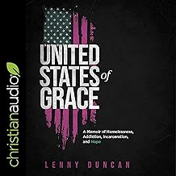[United States of Grace : a memoir of homelessness, addiction, incarceration, and hope](https://ecww.booksys.net/libs/ecww/AddEditItem?&hint=12618). By Lenny Duncan, 2022. (252 Dun)

**Gates, Henry Louis**

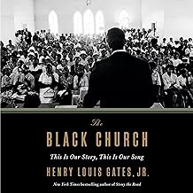Black Church: this is our story, this is our song. By Henry Louis Gates, 2014. (277.3 Gat)

We also have the PBS documentary of the same title and another book by Gates:

[Stony the road : reconstruction, white supremacy, and the rise of Jim Crow](https://ecww.booksys.net/libs/ecww/AddEditItem?&hint=12026). 2019 (973 Gat)

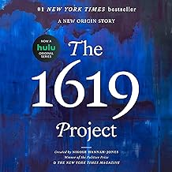**Hannah-Jones, Nikole**

The 1619 Project : a new origin story by Nikole Hannah-Jones. (973 Han)

She also wrote [**The 1619 Project : born on the water**](https://ecww.booksys.net/libs/ecww/AddEditItem?&hint=12199) which is a picture book, 2021, and we have that as well.

## How to Be an AntiracistKendi, Ibram X

## [How to be an Antiracist](https://ecww.booksys.net/libs/ecww/AddEditItem?&hint=11875) By Ibram X Kendi. 2019. (305.8 Ken)

# Kendi also released a later book,

# How to Raise an Antiracist, 2022. (305.8 Ken) and he has a children’s book titled Goodnight racism, 2022) (E Ken)

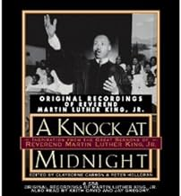**King, Martin Luther Jr.**

A Knock at midnight : inspiration from the great sermons of Reverend Martin Luther King, Jr., 1998 (252 Kin)

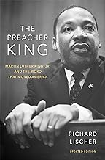**Lishcer, Richard**

Preacher King: Martin Luther King Jr. and the word that moved America. By Richard Lishcer, 2020. (251 Lis)

# Night is Long but Light Comes in the Morning: Meditations for Racial Healing**Meeks, Catherine**

[The night is long but light comes in the morning : meditations for racial healing](https://ecww.booksys.net/libs/ecww/AddEditItem?&hint=12446)   
By Catherine Meeks, 2022. (277.3 Mee)

Living into God's dream : dismantling racism in America Edited by Catherine Meeks, 2016. (305.8 Liv)

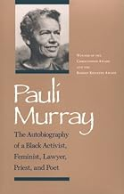**Pauli Murray**

[Pauli Murray: The Autobiography of a Black Activist, Feminist, Lawyer, Priest, and Poet](https://www.amazon.com/Pauli-Murray-Autobiography-Activist-Feminist/dp/0870495968/ref=sr_1_10?crid=10AP4CG1KC4YD&keywords=Pauli+Murray&qid=1695324963&s=books&sprefix=pauli+murray%2Cstripbooks%2C121&sr=1-10),  **1989** (922 Mur)

We also have Song in a weary throat: a memoir of an American pilgrimage (323.092 Mur) and we just received To speak a defiant word : sermons and speeches on justice and transformation, 2023. (323.092 Mur)

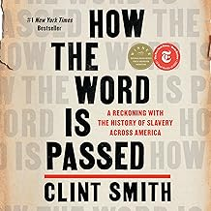**Smith, Clint**

[How the word is passed : a reckoning with the history of slavery across America](https://ecww.booksys.net/libs/ecww/AddEditItem?&hint=12620) By Clint Smith. 20222. (306.3 Smi)

**Smith, Patricia**

Blood dazzler : poems. By Patricia Smith, 2008. (811 Smi)

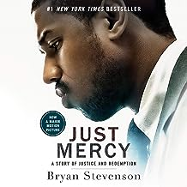**Stevenson, Bryan**

[Just mercy : :a story of justice and redemption](https://ecww.booksys.net/libs/ecww/AddEditItem?&hint=12615). By Bryan Stevenson, 2014 (353.4 Ste)

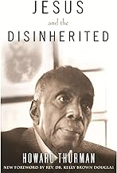**Thurman, Howard.** Jesus and the disinherited. (261.8 Thu)

We also have  [**With head and heart : the autobiography of Howard Thurman**](https://ecww.booksys.net/libs/ecww/AddEditItem?&hint=12383), 1979 ( 280.4 Thu) as well as a DVD and a book about him by Walter Fluker.

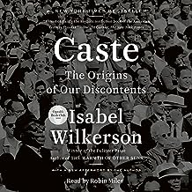**Wilkerson, Isabella**

[Caste : the origins of our discontents](https://ecww.booksys.net/libs/ecww/AddEditItem?&hint=11985) By Isabella Wilkerson, 2020. (305.5 Wil)